Bachelor of Design Department
List of Advanced Learners and Slow Learners (2021-22)
Advanced learners are those students who are university toppers/ active in participation in activities/conferences/societies, have publications/cleared competitive exams, enrolled in online courses etc.
 |  | Advanced Learners
s.no | Name of Student | College Roll No. | Class | Marks in University Exams/House Tests in Previous year/Semester | Member of any society/ organization etc. | Measures Taken/opportunities given to Further enhance skills and confidence of the students | Achievements/ Outcome | Proof of the achievement/ outcome
1. | Lakshita | 53021 | BD 4th sem | 484/600 |  | - Campus Beautification projects  - Workshop/ seminars/ field visits & surveys. | One month internship at Shades interior Studio, 217, Master Tara Singh Nagar, jalandhar. | Attached below
2. | Priyanka | 53012 | BD 4th sem | 466/600 |  | - Souvenir printing/ painting/ designing.  - Market survey for proper understanding  - Workshop/ seminars  - Mentor guidance | One internship inspace Architects chotti baradari, Jalandhar. | Attached below
3. | Simranjeet | 5903 | BD 8th Sem | 53618/4400 |  | - Campus Beautification projects  - Workshop/ seminars/ field visits & surveys. | Internship at Saurabh Gupta,  3rd march -7th may 2022 | https://drive.google.com/file/d/12Hj-1xDWLfZgqcr3twgj07sAHf1H2oyf/view?usp=sharing
4. | Nisha | 5904 | BD 8th Sem | 3310/4400 |  | - Souvenir printing/ painting/ designing.  - Workshop/ seminars  - Market survey for proper understanding  - Mentor guidance | Internship at the violet Dresser, 24thfeb – 24thapril 2022 | https://drive.google.com/file/d/12Hj-1xDWLfZgqcr3twgj07sAHf1H2oyf/view?usp=sharing
5. | Sukhwansh | 5909 | BD 8th Sem | 3557/4400 |  | - Souvenir printing/ painting/ designing.  - Market survey for proper understanding  - Workshop/ seminars  - Mentor guidance | Internship at AG’s International, 8th march- 8th may 2022 | https://drive.google.com/file/d/12Hj-1xDWLfZgqcr3twgj07sAHf1H2oyf/view?usp=sharing
6. | Sonia | 5901 | BD 8th Sem | 3352/4400 |  | - Souvenir printing/ painting/ designing.  - Market survey for proper understanding  - Workshop/ seminars  - Mentor guidance | Internship at Rankeshwar Collection, Ludhaina. 7th march – 29thapril 2022 | https://drive.google.com/file/d/12Hj-1xDWLfZgqcr3twgj07sAHf1H2oyf/view?usp=sharing
7. | Komalpreet Kaur | 5912 | BD 8th Sem | 3788/4400 |  | - interenship  - Souvenir printing/ painting/ designing.  - Market survey for proper understanding  - Workshop/ seminars  - Mentor guidance | Internship at ASWM Spinning Mills,, Amritsar, 2nd march- 30thapril 2022 | https://drive.google.com/file/d/12Hj-1xDWLfZgqcr3twgj07sAHf1H2oyf/view?usp=sharing
8. | Rupika | 5910 | BD 8th Sem | 3716/4400 |  | - Souvenir printing/ painting/ designing.  - Market survey for proper understanding  - Workshop/ seminars  - Mentor guidance | Internship at Rankeshwar Collection, Ludhaina. 14th march- 29thapril | https://drive.google.com/file/d/12Hj-1xDWLfZgqcr3twgj07sAHf1H2oyf/view?usp=sharing
9. | Sukhmani Kaur | 5908 | BD 8th Sem | 3873/4400 |  | - internship.  - Souvenir printing/ painting/ designing.  - Market survey for proper understanding  - Workshop/ seminars  - Mentor guidance | Internship at Shades Interior Studio, Master tara Singh Nagar, Jalandhar, 28thfeb- 28th may 2022 | https://drive.google.com/file/d/12Hj-1xDWLfZgqcr3twgj07sAHf1H2oyf/view?usp=sharing
10. | Poonam | 5906 | BD 8th Sem | 3336/4400 |  | - Recycling projects for college under the guidance of mentor  - Workshops/seminars/ presentation. | Internship at Riwaz Designer studio, BanaChowk, Amritsar Road, Kapurthala, 1st march- 30thapril 2022 | https://drive.google.com/file/d/12Hj-1xDWLfZgqcr3twgj07sAHf1H2oyf/view?usp=sharing
11. | Sonia | 5911 | BD 8th Sem | 3352/4400 |  | - Campus Beautification projects  - Workshop/ seminars/ field visits & surveys. | Internship at Riwaz Designer studio, BanaChowk, Amritsar Road, Kapurthala, 1st march- 30thapril 2022 | https://drive.google.com/file/d/12Hj-1xDWLfZgqcr3twgj07sAHf1H2oyf/view?usp=sharing
12. | Prabh Noor Kaur | 5919 | BD 8th Sem | 3925/4400 | Class representative.  Secretary Designng Hub Society. | - Souvenir printing/ painting/ designing.  - Market survey for proper understanding  - Workshop/ seminars  - Mentor guidance | Internship at ASWM Spinning Amritsar, 2nd march- 30thapril 2022 | https://drive.google.com/file/d/12Hj-1xDWLfZgqcr3twgj07sAHf1H2oyf/view?usp=sharing
13. | Harsimran Kaur | 5916 | BD 8th Sem | 3680/4400 |  | - Campus Beautification projects  - Workshop/ seminars/ field visits & surveys. | Internship at Chhabra Collection, Jalandhar , 1st march- 30thapril 2022 | https://drive.google.com/file/d/12Hj-1xDWLfZgqcr3twgj07sAHf1H2oyf/view?usp=sharing
14. | Arshjot Kaur | 5914 | BD 8th Sem | 3690/4400 |  | - Souvenir printing/ painting/ designing.  - Workshop/ seminars  - Market survey for proper understanding  - Mentor guidance | Internship at AG’s International, Ladowali Road , Jalandhar ,2nd march- 8th may 2022 | https://drive.google.com/file/d/12Hj-1xDWLfZgqcr3twgj07sAHf1H2oyf/view?usp=sharing
15. | Neha | 5913 | BD 8th Sem | 3596/4400 |  | - Souvenir printing/ painting/ designing.  - Market survey for proper understanding  - Workshop/ seminars  - Mentor guidance | Internship at Adaa De Designer Studio, Kapurthala Road, jalandhar, 2nd march- 2nd may 2022 | https://drive.google.com/file/d/12Hj-1xDWLfZgqcr3twgj07sAHf1H2oyf/view?usp=sharing
16. | Chahat | 5902 | BD 8th Sem | 3536/4400 |  | - Souvenir printing/ painting/ designing.  - Market survey for proper understanding  - Workshop/ seminars  - Mentor guidance | Internship at SatkartarDesigner Dresses, Jalandhar,18thfeb -18thapril 2022 | https://drive.google.com/file/d/12Hj-1xDWLfZgqcr3twgj07sAHf1H2oyf/view?usp=sharing
17. | Heena Chowdhary | 5920 | BD 8th Sem | 3305/4400 |  | - interenship  - Souvenir printing/ painting/ designing.  - Market survey for proper understanding  - Workshop/ seminars  - Mentor guidance | Internship at The Violet Dresser by Harleenkaur , Jalandhar ,24th feb-30thapril 2022 | https://drive.google.com/file/d/12Hj-1xDWLfZgqcr3twgj07sAHf1H2oyf/view?usp=sharing
18. | Rishika | 5917 | BD 8th Sem | 3761/4400 |  | - Souvenir printing/ painting/ designing.  - Market survey for proper understanding  - Workshop/ seminars  - Mentor guidance | Internship at AG’s International, Ladowali Road, Jalandhar,8th march-8th may 2022 | https://drive.google.com/file/d/12Hj-1xDWLfZgqcr3twgj07sAHf1H2oyf/view?usp=sharing
19. | Ranjana | 5915 | BD 8th Sem | 3573/4400 |  | - internship.  - Souvenir printing/ painting/ designing.  - Market survey for proper understanding  - Workshop/ seminars  - Mentor guidance | Internship at 13 Design, Building Designers, Jalandhar,10th march- 14 may 2022 | https://drive.google.com/file/d/12Hj-1xDWLfZgqcr3twgj07sAHf1H2oyf/view?usp=sharing

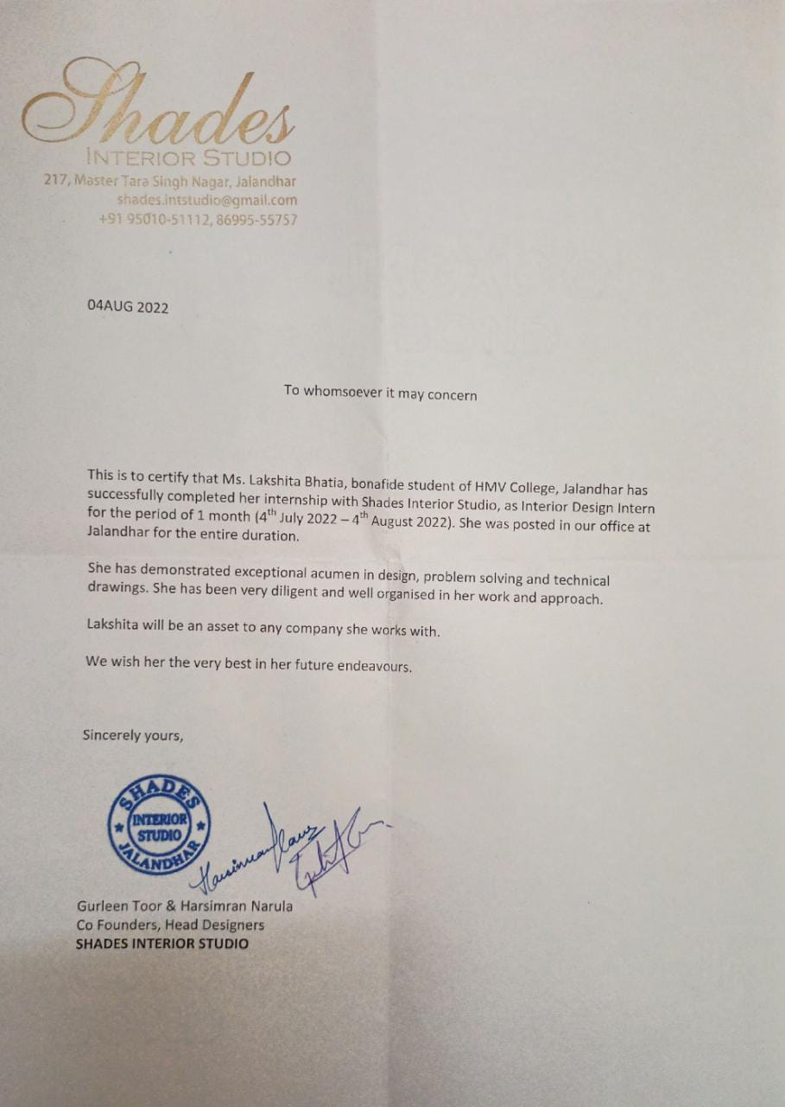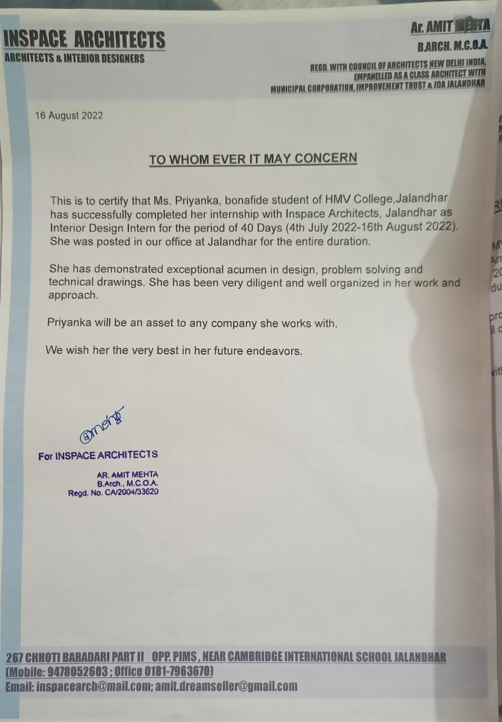
Sr No 1 Sr No 2
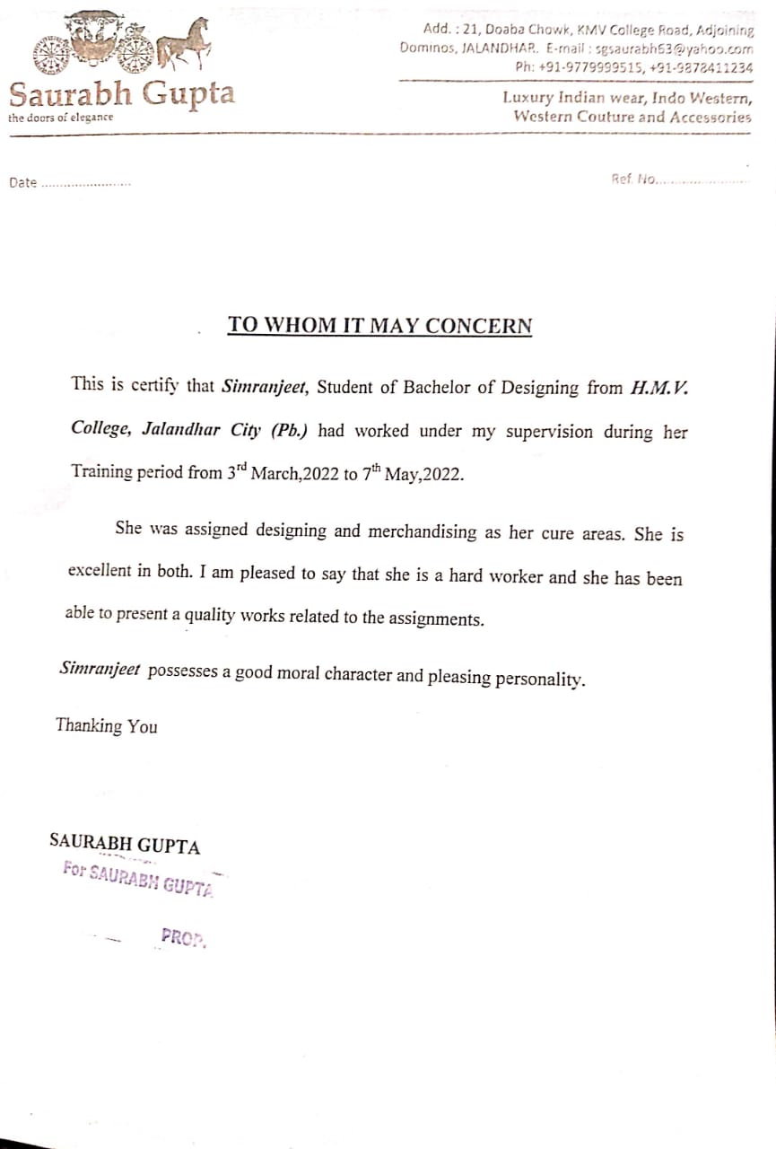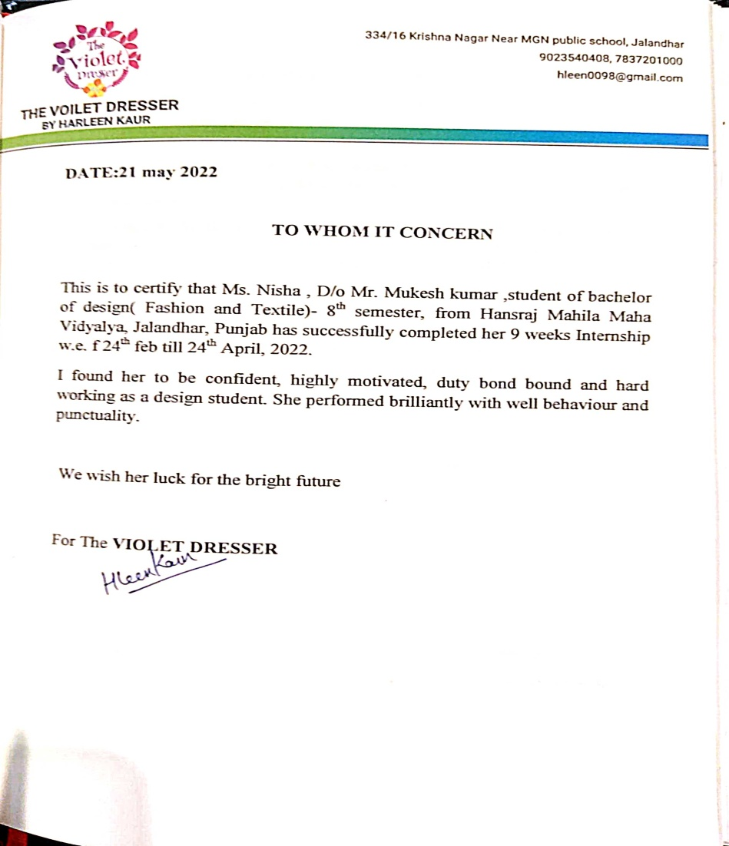
Sr No 3 Sr No 4

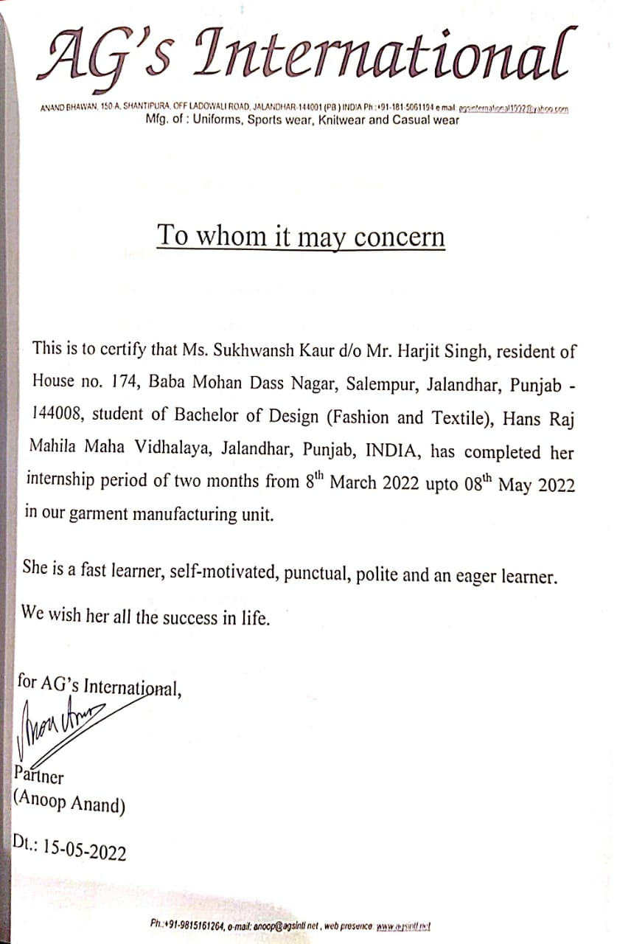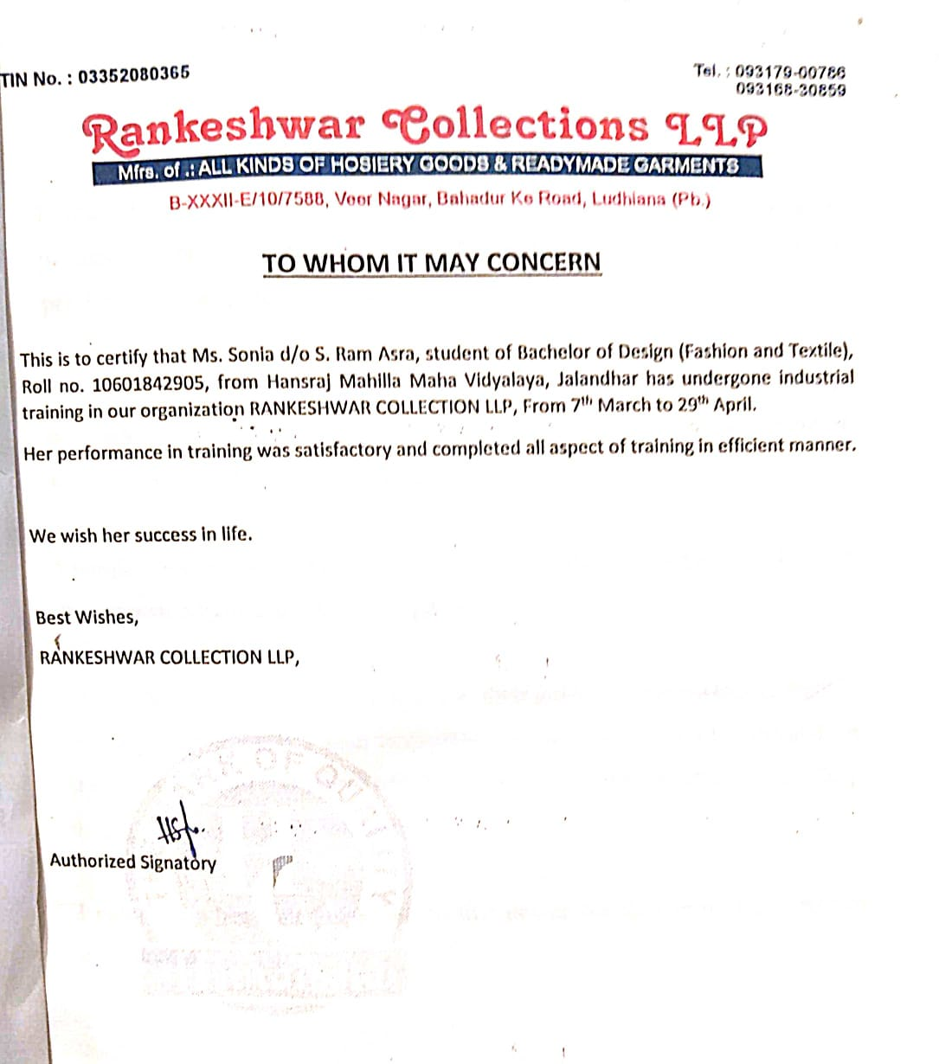
Sr No 5 Sr No 6

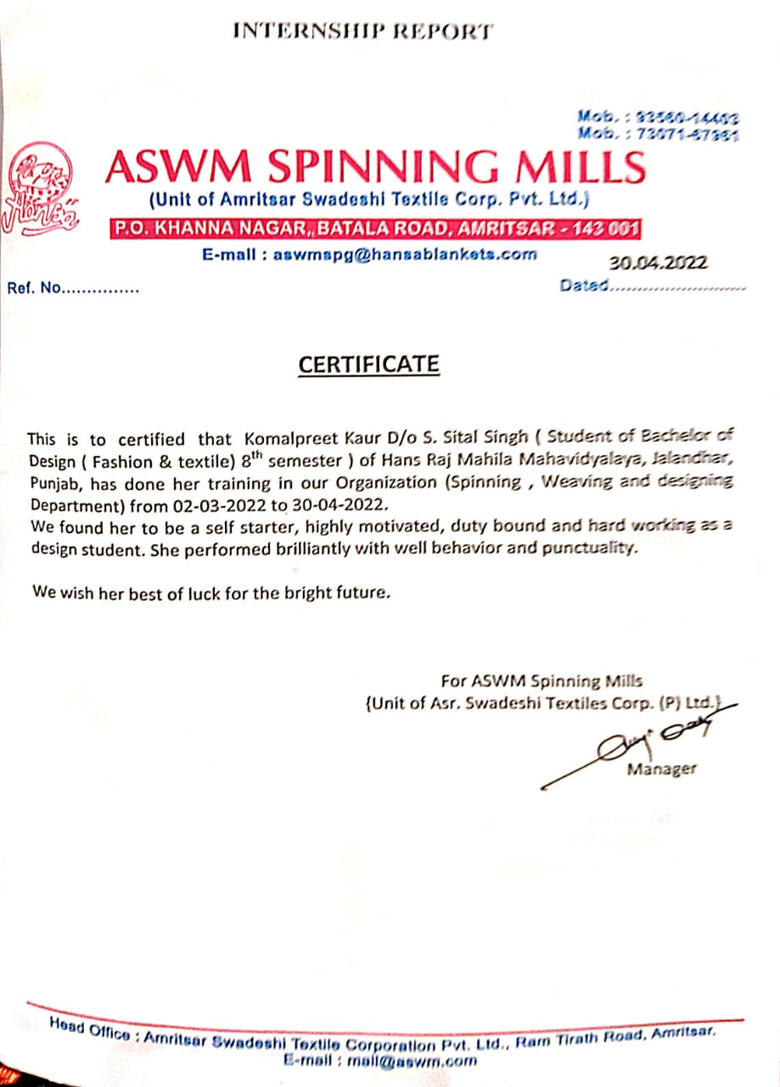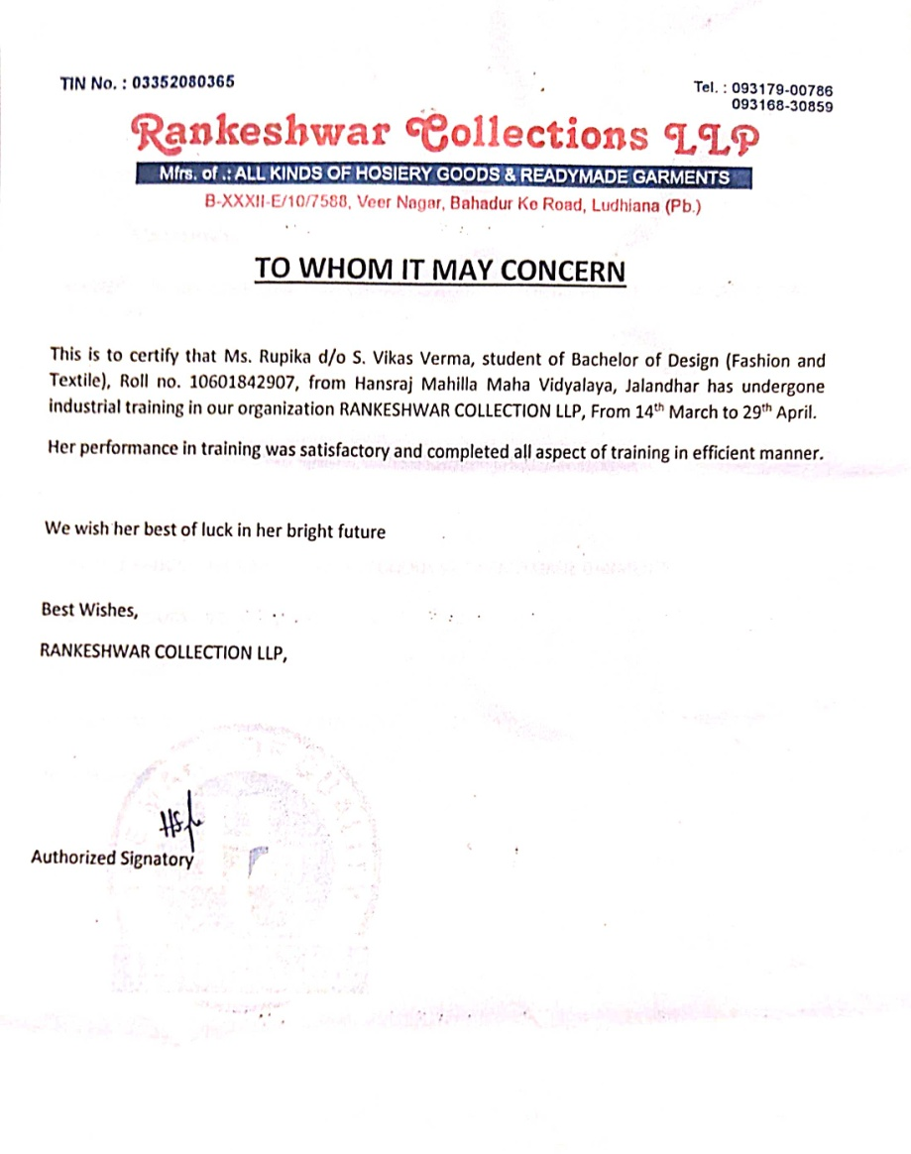
Sr No 7 Sr No 8

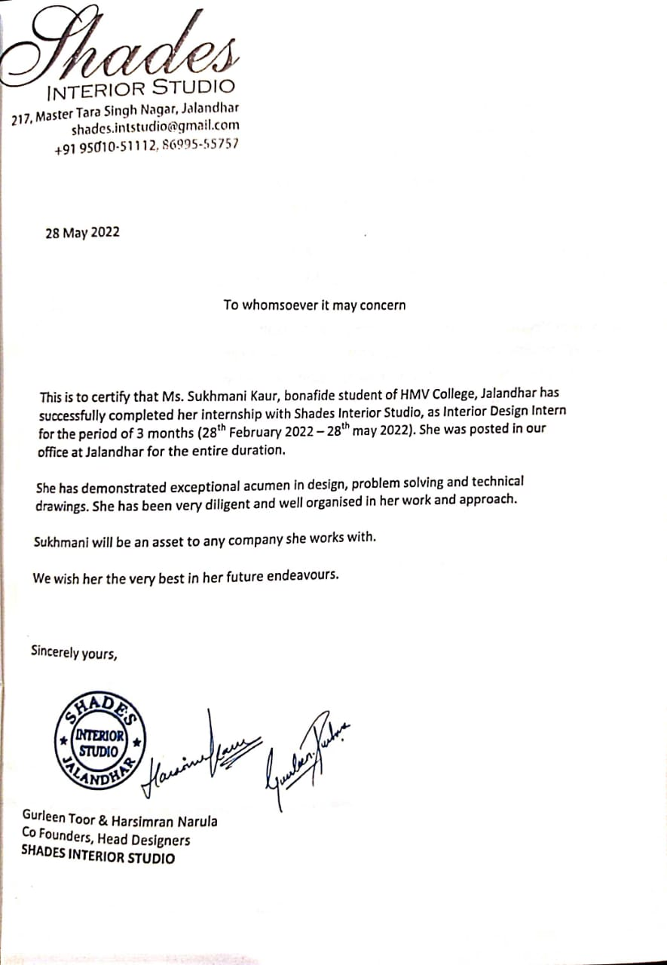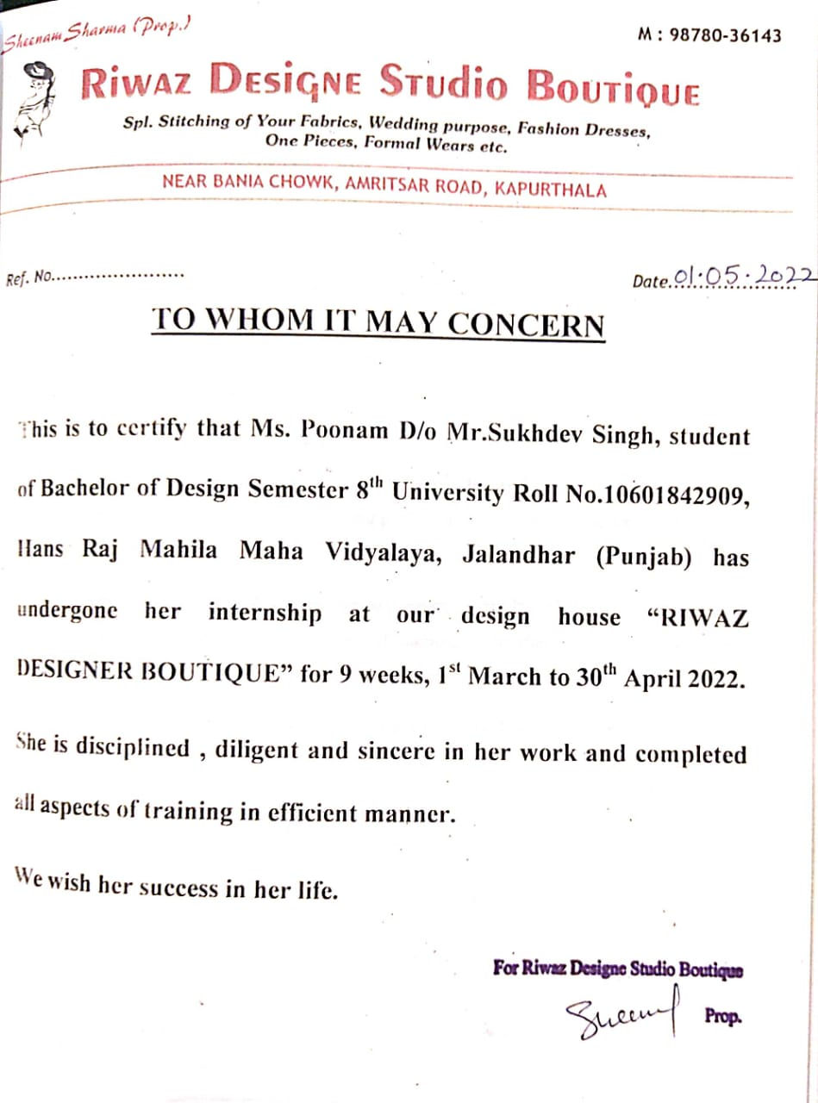
Sr No 9 Sr No 10

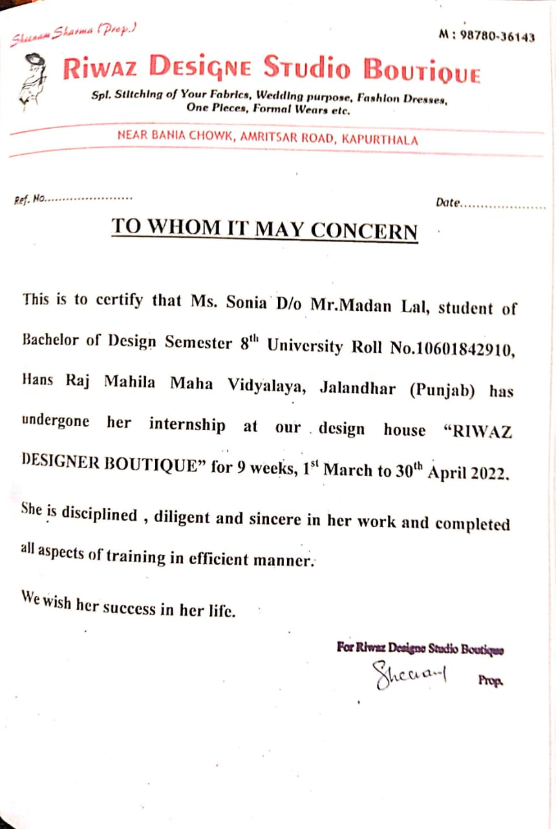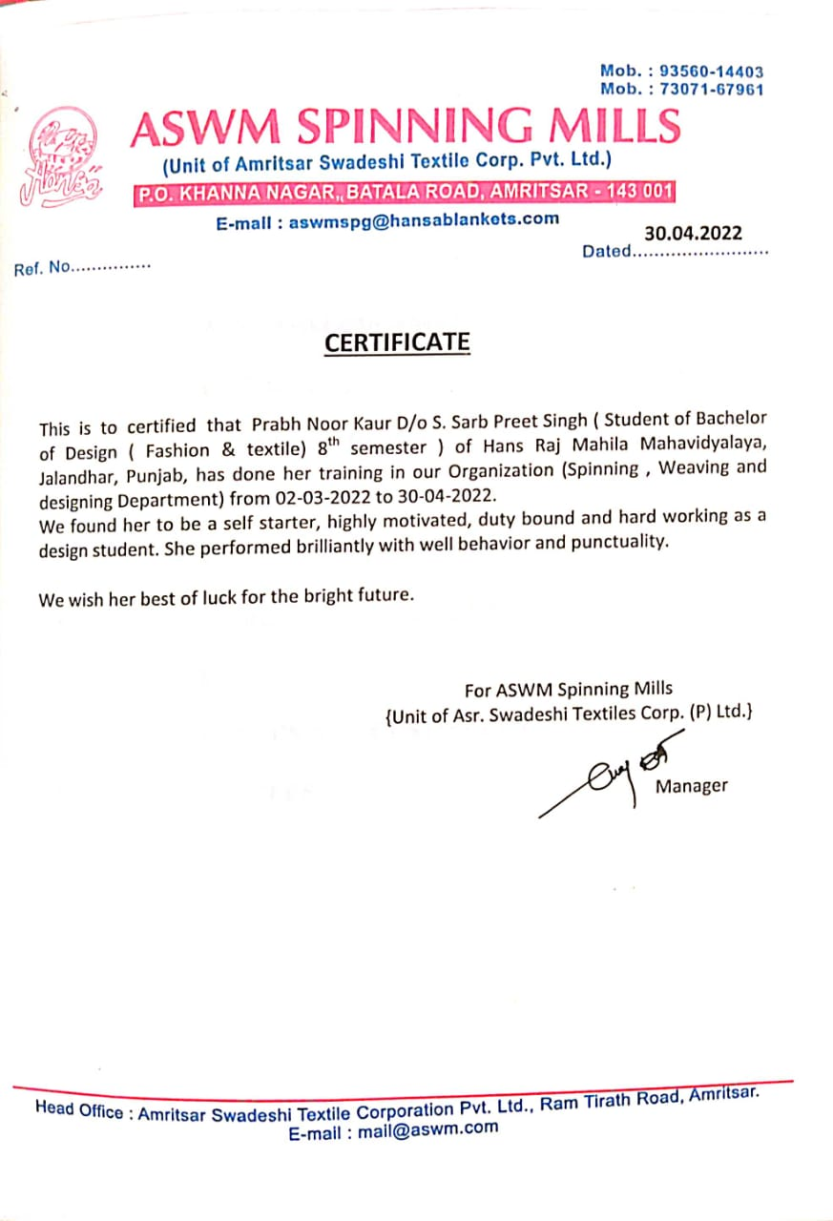
Sr No 1 1 Sr No. 12

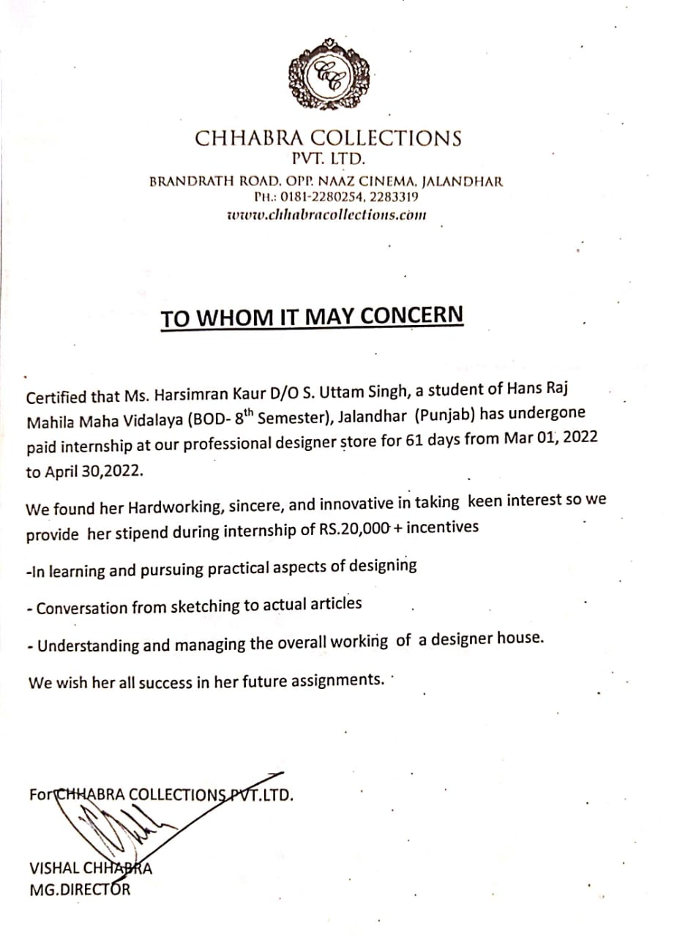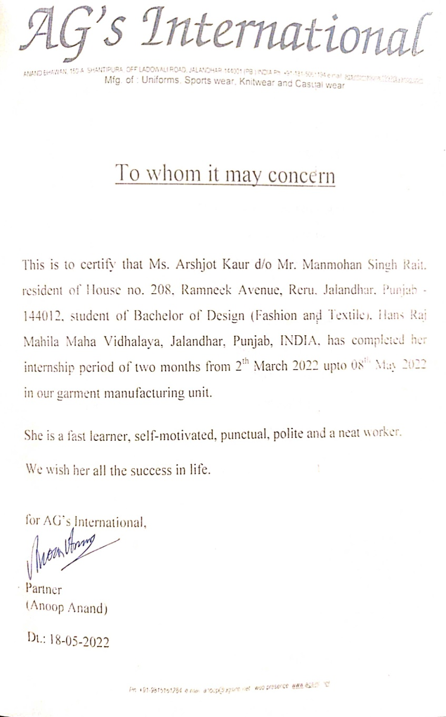
Sr No 13 Sr No 14

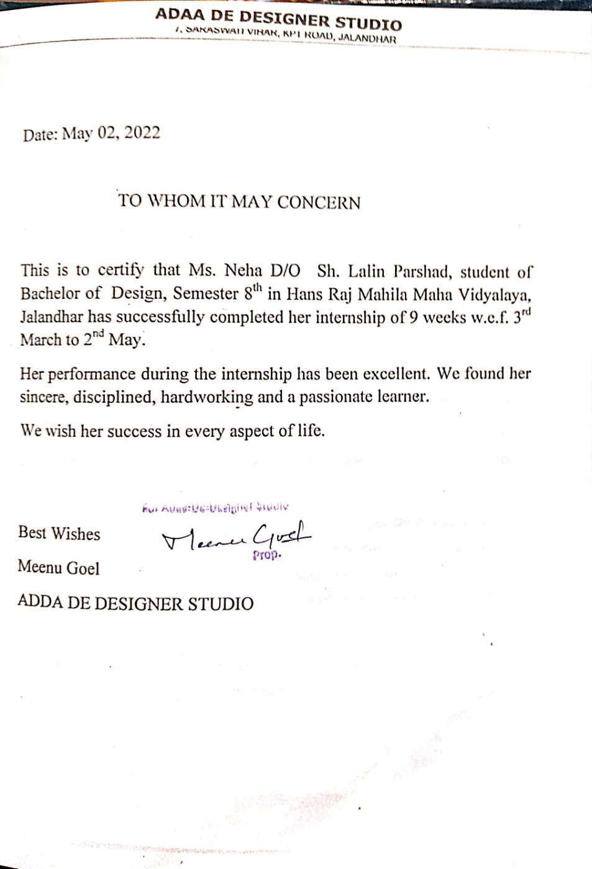 Sr No 15

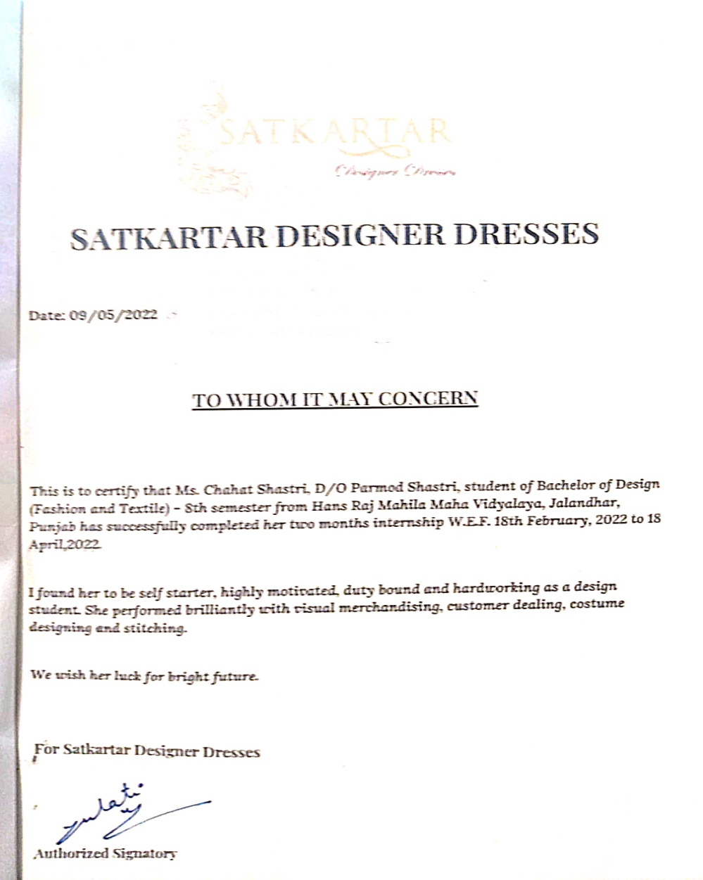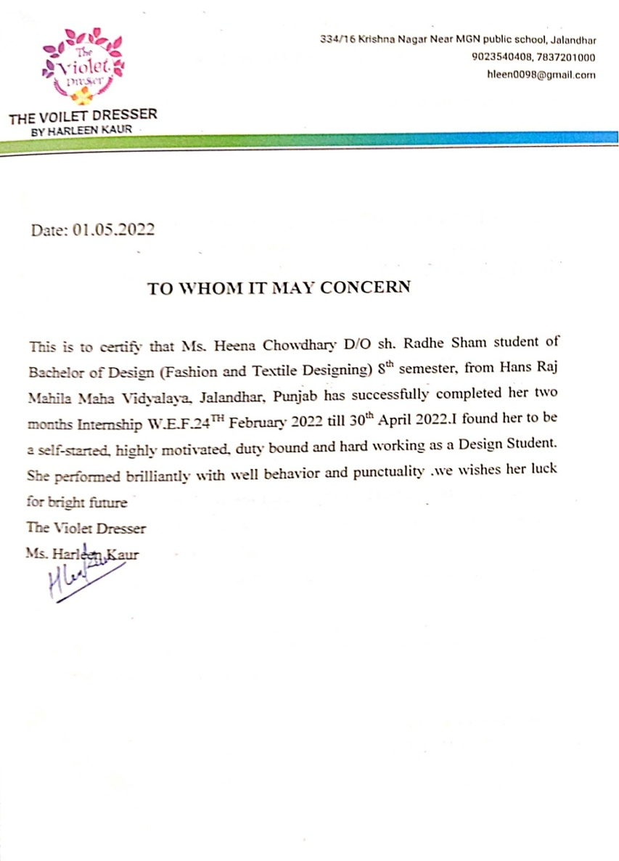
Sr No 16 Sr No 17

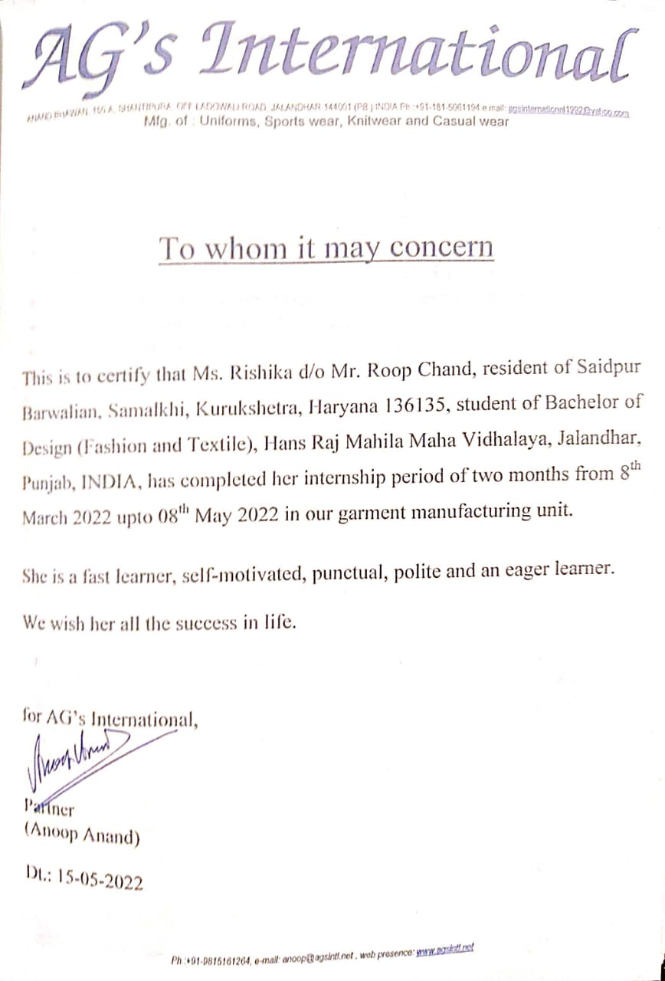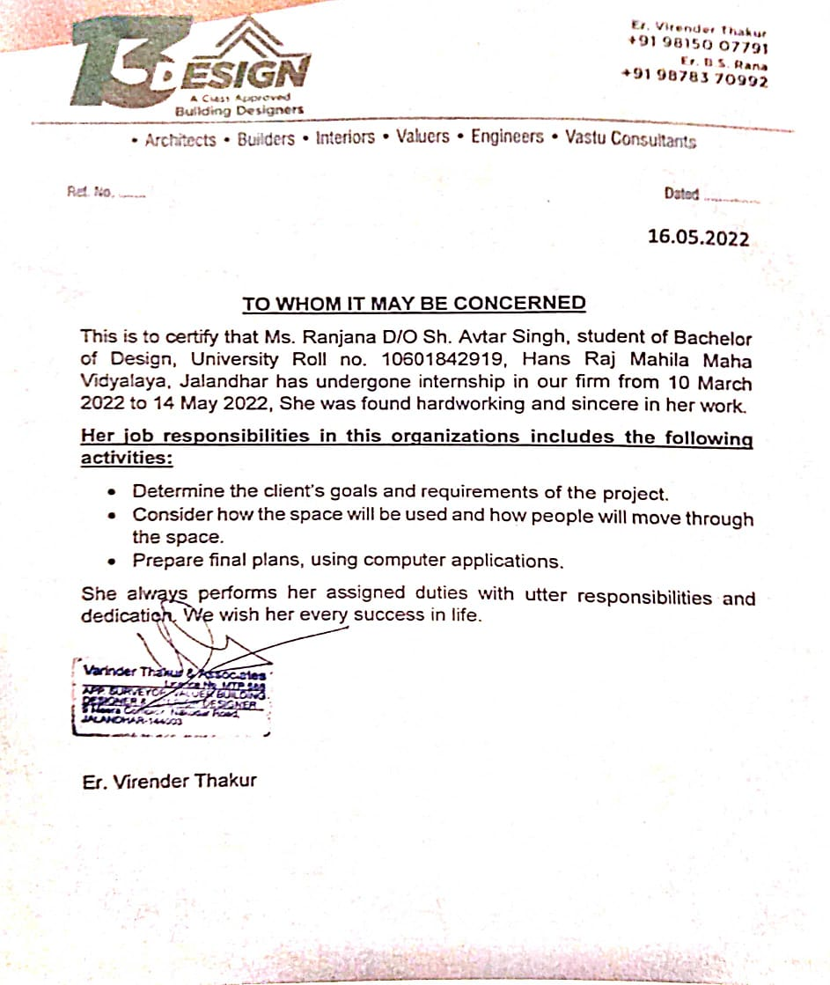

Sr No 18 Sr No 19

 | Slow Learners
S.No | Name of Student | Roll No. | Class | Marks in University Exams/House tests | Remedial Measures Taken | Outcome/ Achievements | Proofs (if any)
 | Poonam | 5906 | BD 7th Sem  BD 8th sem | 409//600  584/600 | Experiment with design materials,  Workshop, demonstrations and guidance by mentor | Enhanced designing skill and confidence | Class taken by Dr Rakhi Mehta
 | sonia | 5911 | BD 7th Sem  BD 8th sem | 540/600  580/600 | Workshop, demonstrations and guidance by mentor | Enhanced designing skill and confidence | Class taken by Dr Rakhi Mehta
 | Sukhwansh kaur | 5908 | BD7th Sem  BD 8th sem sem | 535/600  576/600 | Workshop, demonstrations and guidance by mentor | Enhanced designing skill and confidence | Class taken by Dr Rakhi Mehta
 | Simran |  | BD 1st Sem  BD 2nd Sem | 334/400  264/400 | Prcatical Demonstration, Presentation, Experimental Learnng. | Enhanced designing skill and confidence | Class taken by Dr Rakhi Mehta
 | Shailza Jain |  | BD 5th Sem | 379/600 | Prcatical Demonstration, Presentation, Exprimental Learning. | Enhanced designing skill and confidence | Class taken by Dr Rakhi Mehta
 | Sukhman |  | BD 5th Sem  BD 6th Sem | 324/600  348/500 | Prcatical Demonstration, Discussions, power point Presentation. | Enhanced designing skill and confidence | Class taken by Dr Rakhi Mehta

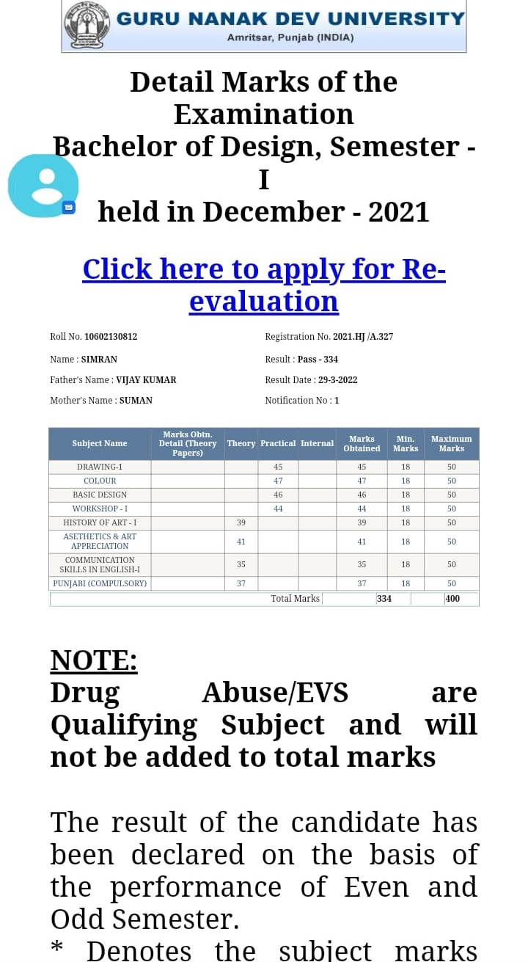 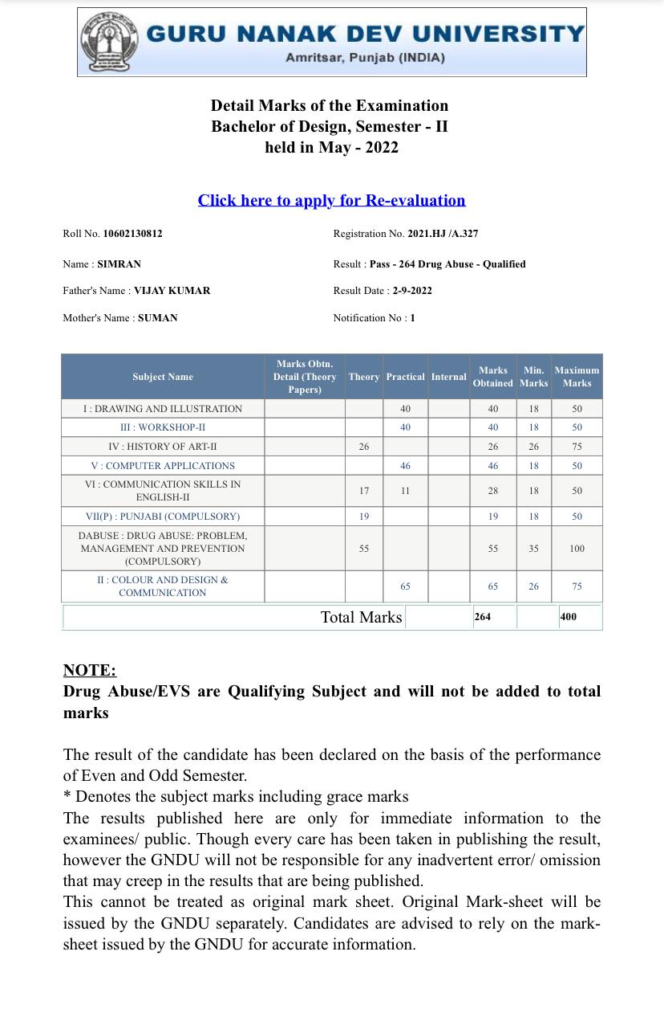 Sse

S
Sr No 4

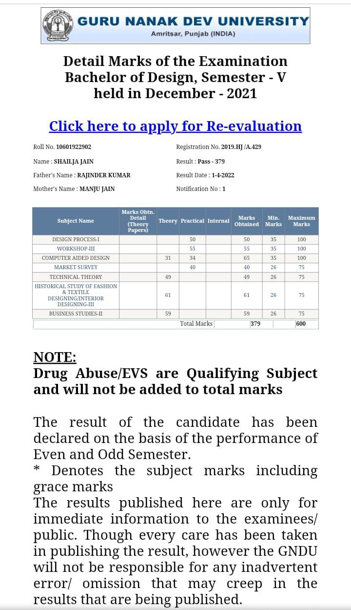
Sr No5

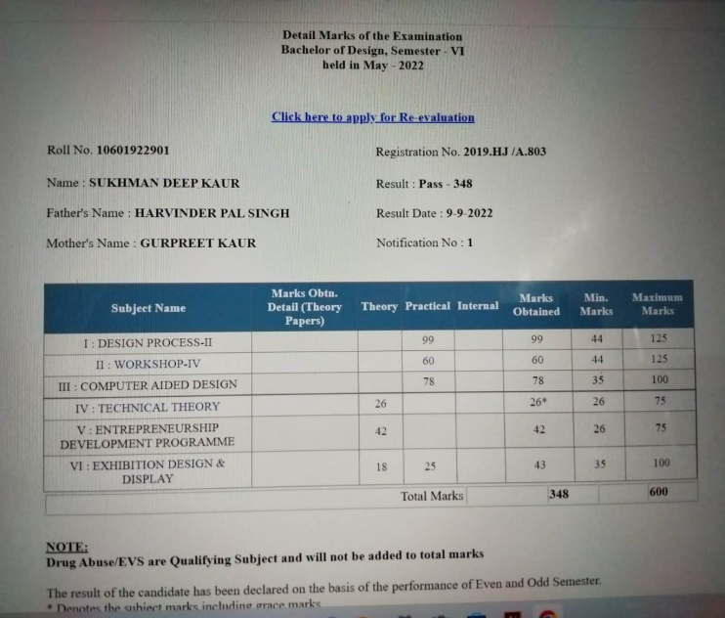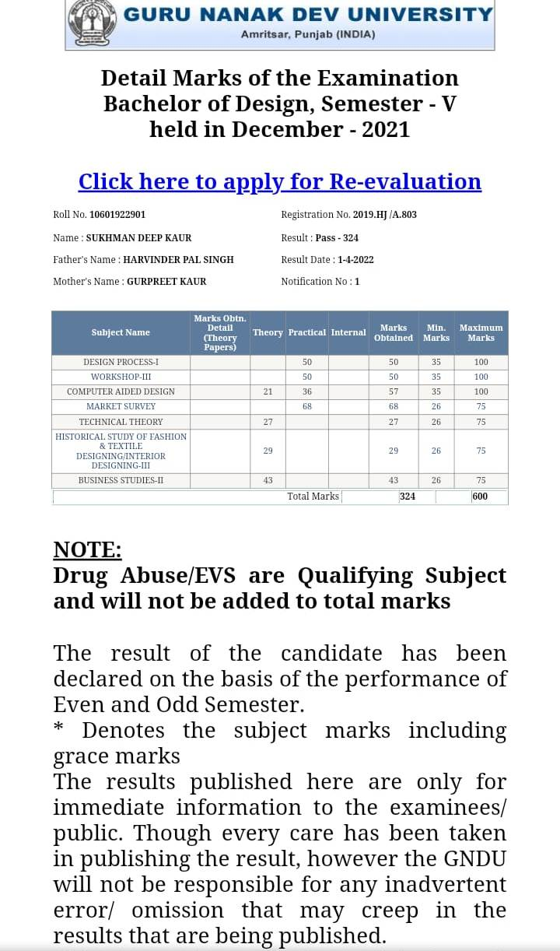
Sr No 6

Sr

